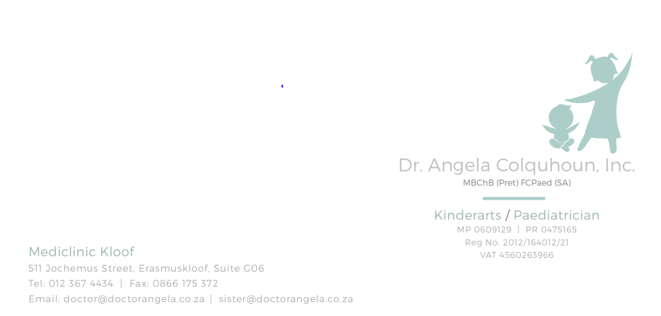
Patient education: Ear infections (otitis media) in children
What is an ear infection?
An ear infection is a condition that can cause pain in the ear, fever, and trouble hearing. Ear infections are common in children.
Ear infections often occur in children after they get a cold. Fluid can build up in the middle part of the ear behind the eardrum. This fluid can become infected and press on the eardrum, causing it to bulge (figure 1). This causes symptoms.
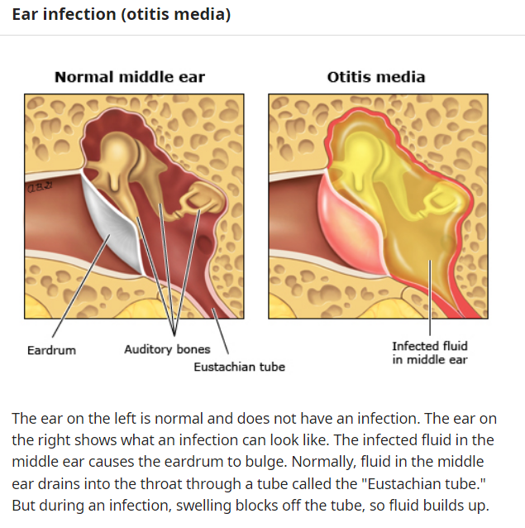
In some children, some fluid can stay in the ear for weeks to months after the pain and infection have gone away. This fluid can cause hearing loss that is usually mild and temporary. If the hearing loss lasts a long time, it can sometimes lead to problems with language and speech, especially in children who are at risk for problems with language or learning.

What are the symptoms of an ear infection?
In infants and young children, the symptoms include:
●Fever
●Pulling on the ear
●Being more fussy or less active than usual
●Having no appetite and not eating as much
●Vomiting or diarrhea
In older children, symptoms often include ear pain or temporary hearing loss.
How do I know if my child has an ear infection?
If you think that your child has an ear infection, see a doctor or nurse. The doctor or nurse should be able to tell if your child has an ear infection. They will ask about symptoms, do an exam, and look in your child's ears.
Is there anything I can do to help my child feel better?
Yes. You can give your child medicine, such as paracetamol (sample brand name: Panado, Calpol) or ibuprofen (sample brand names:Nurofen) to help with pain. But never give aspirin to a child younger than 18 years old. Aspirin can cause a dangerous condition called Reye syndrome.
Most doctors do not recommend treating ear infections with cold and cough medicines. These medicines can have dangerous side effects in young children.
Do not put anything in your child's ear unless their doctor or nurse told you to.
Airplane travel can make ear pain worse, especially as the plane starts to land. If your child is a baby, it might help to have them suck on a pacifier or bottle during landing. If your child is older, chewing gum or food might help.
How are ear infections treated?
Doctors can treat ear infections with antibiotics. These medicines kill the bacteria that cause some ear infections. But doctors do not always prescribe these medicines right away. That's because many ear infections are caused by viruses – not bacteria – and antibiotics do not kill viruses. Plus, many children heal from ear infections without antibiotics.
Doctors usually prescribe antibiotics to treat ear infections in infants younger than 2 years old.
Your child's doctor might suggest watching their symptoms for 1 or 2 days before trying antibiotics if:
●Your child is older than 2 years.
●Your child is generally healthy.
●The pain and fever are not severe.
You and your doctor should discuss whether or not to give your child antibiotics. This will depend on your child's age, health problems, and how many ear infections they have had in the past.

When can my child go back to school or day care?
In general, your child can go back to school or day care when they are feeling better and no longer have a fever. Ear infections are not contagious.
What problems should I watch for?
You should call the doctor or nurse if:
●Your child's symptoms get worse at any time.
●Your child is not getting better after 2 days.
●There is fluid draining from your child's ear.
You should also see the doctor or nurse a few months after an ear infection if your child is younger than 2 or has language or learning problems. Your doctor or nurse will do an ear exam to make sure that the fluid is gone. Your child might also need follow-up tests to check their hearing.
If the fluid in the ear is causing hearing loss and does not go away after several months, your doctor might suggest treatment to help drain the fluid. This involves a surgery in which a doctor places a small tube in the eardrum (figure 2).
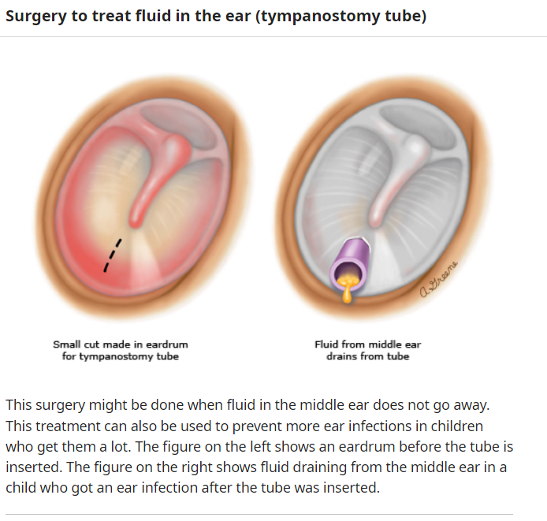
Can ear infections be prevented?
You can lower your child's risk of getting an ear infection by:
●Keeping them away from places where people smoke
●Having them wash their hands often
●Keeping them away from people who are sick with a cold or other viral infection
●Making sure that they get all of their recommended vaccines

If your child gets a lot of ear infections, ask the doctor what you can do to prevent repeat infections. The doctor might talk to you about the risks and benefits of:
●Giving your child an antibiotic every day during certain months of the year
●Doing surgery to place a small tube in your child's eardrum

